
COMSATS University Islamabad,
Abbottabad Campus
SOFTWARE DESIGN DESCRIPTION
(SDD DOCUMENT)
for
SignSpeak: Word-Level Pakistan Sign Language Recognition
Version 1.0
By
AbuZar Babar (CIIT/FA22-BSE-133/ATD)
Mohib Ullah Khan Sherwani (CIIT/FA22-BSE-125/ATD)
M. Abdullah Umar (CIIT/FA22-BSE-126/ATD)
Supervisor
Dr. Rab Nawaz Jadoon

Bachelor of Science in Computer Science (2022-2026)

Table Of Contents
1. Introduction 5
2. Design methodology and software process model 5
2.1 Architectural design 6
2.2 Activity Diagram 7
3. Design models 7
3.1 Class Diagram 8
3.2 Sequence Diagram 9
3.3 Deployment Diagram 10
3.4 Package Diagram 11
3.5 JSON Tree: 11
4. Data design 12
4.1 Cloud Database: Firebase Firestore 12
4.2 Data Dictionary 14
5. Algorithm & Implementation 15
5.1 Frame Reception Workflow (Backend API Layer) 15
5.2 Landmark Extraction 16
5.3 Model Inference 16
6. Software requirements traceability matrix 17
6.1 Functional Requirements Traceability Matrix 17
6.2 Non-Functional Requirements Traceability Matrix 18
7 Human interface design 19
7.1 Screen images 19
7.2 Screen objects and actions 22
Appendix I 22

List of Figures
Figure 1: Architecture Diagram 6
Figure 2: Activity Diagram 7
Figure 3: Class Diagram 8
Figure 4: Sequence Diagram 9
Figure 5: Deployment Diagram 10
Figure 6: Package Diagram 11
Figure 7: JSON Tree 11
Figure 11: Translation Screen 21
Figure 12: Dictionary 21
Figure 13: Admin Dashboard 22
Figure 14: Admin Complaints 22

List of Tables
Table 1: Collection Complaints 11
Table 2: Data Dictionary 12
Table 3: Functional Requirements Traceability matrix 16
Table 4: Non-functional Requirements Traceability matrix 16

Revision History
Name | Date | Reason for changes | Version

Application Evaluation History

Comments (by committee)  *include the ones given at scope time both in doc and presentation | Action Taken

Supervised by
Dr. Rab Nawaz Jadoon
Signature______________

Introduction
This document describes the software design for SignSpeak, translating SRS requirements into a concrete architecture and implementation plan. It covers architecture, module decomposition, data schemas, algorithms/pseudocode, UI design, deployment and non-functional considerations. The intent is to provide engineers a clear blueprint for implementation and a basis for diagrams, tests and CI/CD.

Purpose
Provide design decisions, interfaces, and algorithms sufficient to implement the mobile app (Flutter), backend (FastAPI), and ML pipeline (training, dataset creation).

Scope
Covers client (mobile), server (inference), data storage, and the ML pipeline. Does not include raw dataset creation details inside use-case diagrams.

Design methodology and software process model
Approach: Modular Object-Oriented design for client + service components; modular script/service design for ML pipeline.
Process model: Iterative Agile.
Rationale: Frequent retraining and user feedback require iterative releases; modularity helps maintainability and testability.

System overview
High-level summary: Hybrid client-server system with backend inference:
- On-device: Capture frames and send to backend.
- Backend: Full backend inference, recognizing gestures and returning words with confidence scores.
Primary components:
- Mobile App (Flutter): Camera capture, Frame Compression (FFMPG), UI.
- Backend (FastAPI): inference router, recognition service, analytics.
- ML Pipeline: data preprocessing, training, validation.
- Storage: User info, admin info stored in Firebase, Complaints stored in Firestore.

Normal high-level flow:
- Capture frames > Compress frames > send to backend for inference.
- Send sequence to via POST /infer.
- Recognition returns tokens.
- Mobile UI displays result.

Fault handling
- Low confidence > UI indicates uncertainty and suggests repositioning.
- Network unavailable and cloud mode selected > fallback to on-device quick tokens display.

2.1 Architectural design
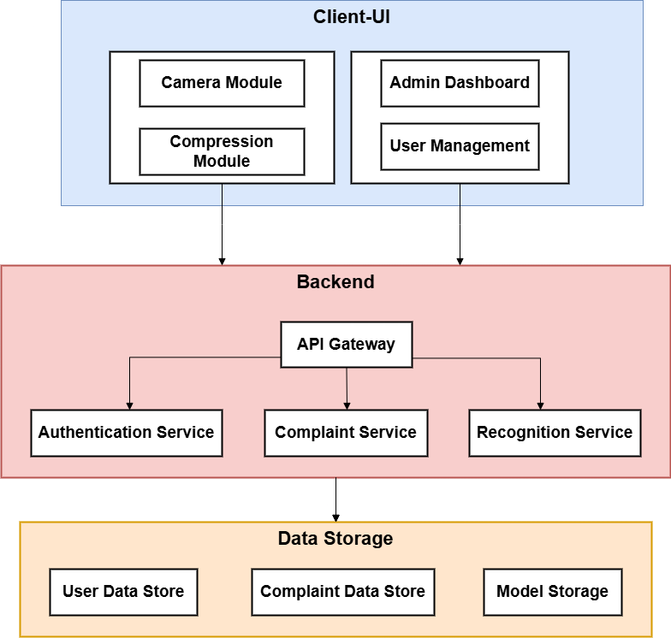
Figure 1: Architecture Diagram

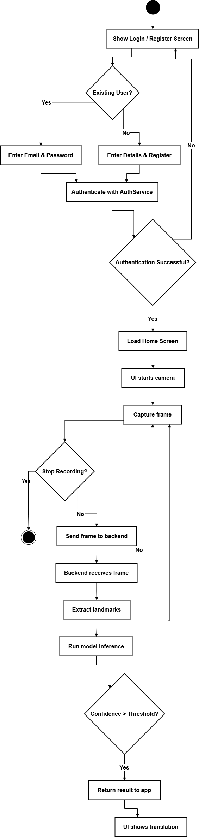
2.2 Activity Diagram

Figure 2: Activity Diagram

Design models
This section presents the key design models including class, sequence and other diagrams that illustrate the structure and dynamic behaviour of the SignSpeak system.

Class Diagram
The Figure 3 shows the main objects of the system and the relationships among them.
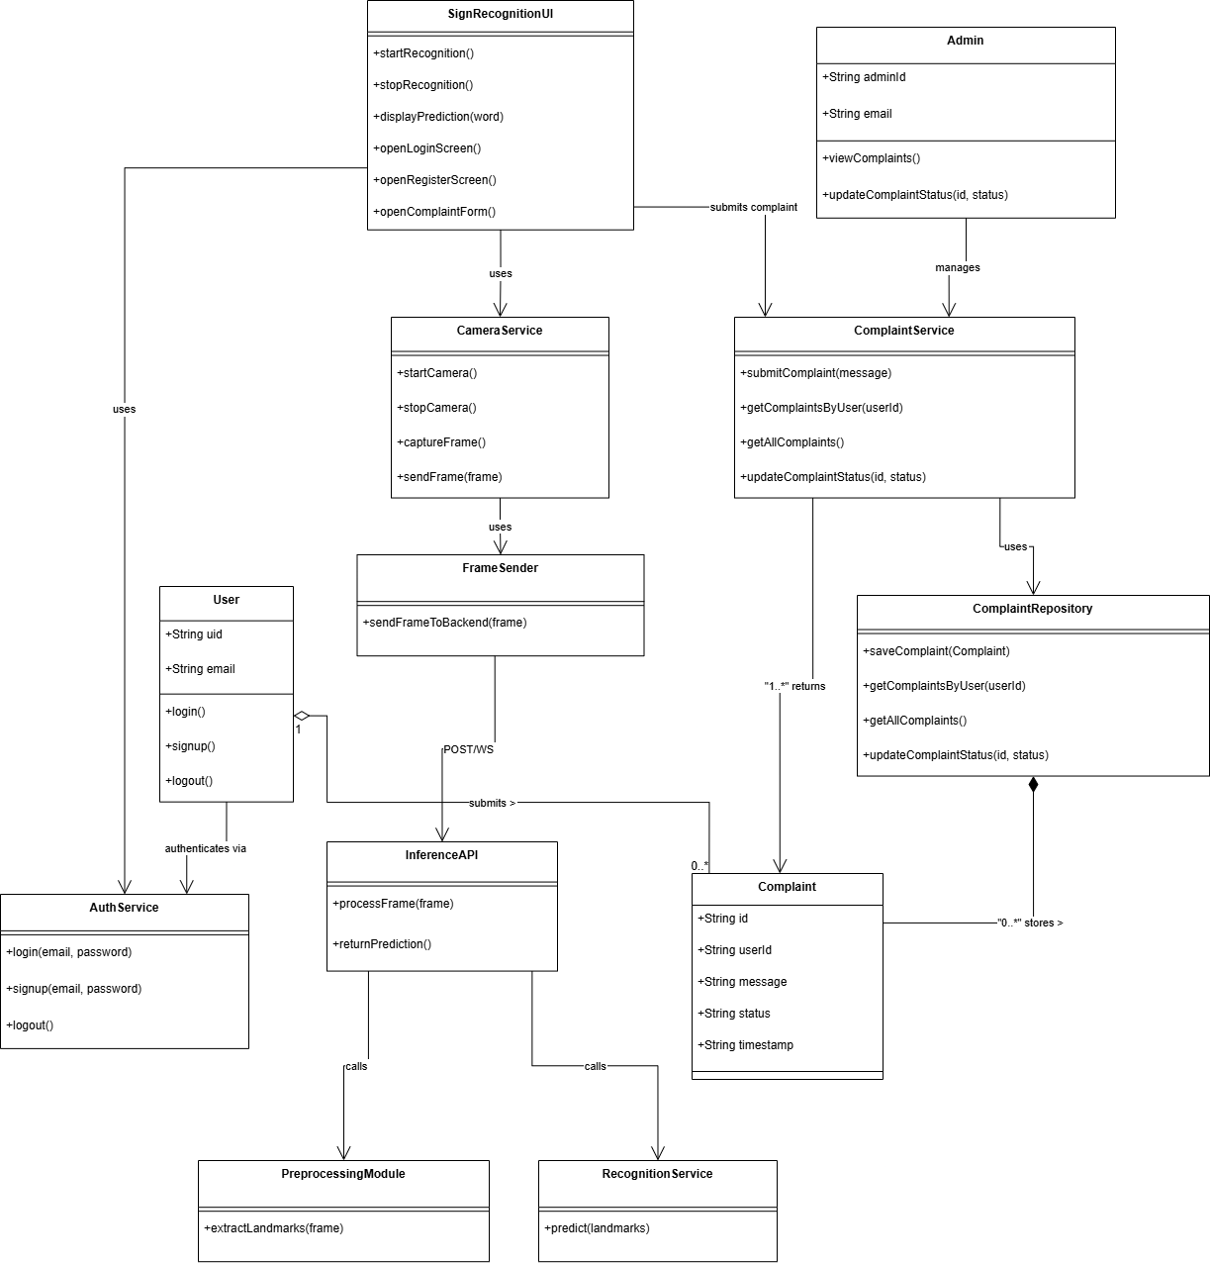
Figure 3: Class Diagram

Sequence Diagram
The Figure 4 represent the flow of interactions between objects for major system operations. The diagram shows how clients, backend services, and data storage modules communicate through method calls or events to complete a task.
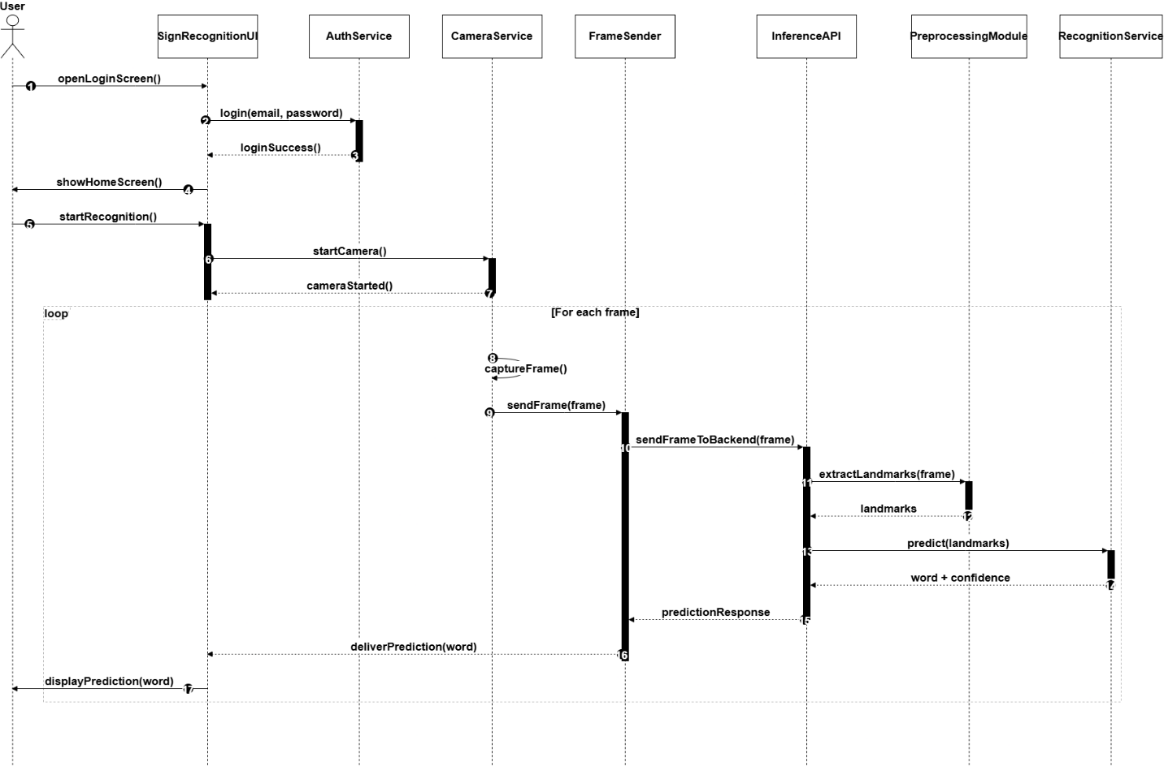
Figure 4: Sequence Diagram

Deployment Diagram
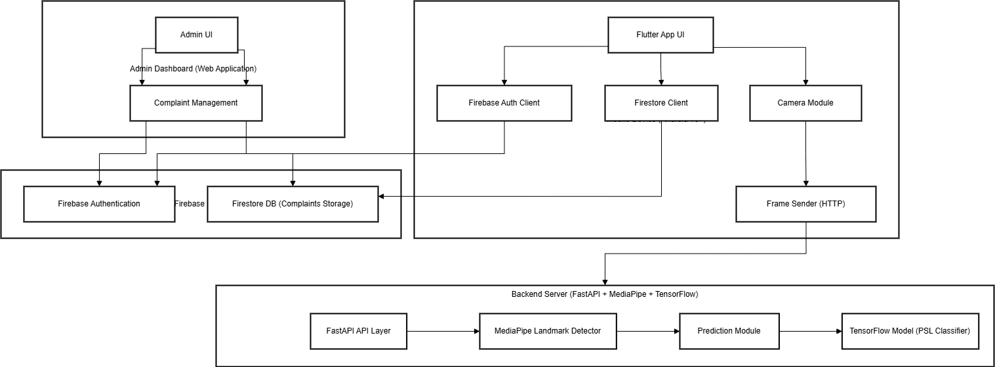
Figure 5: Deployment Diagram

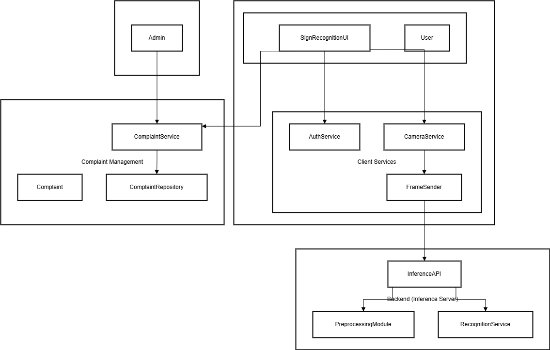
Package Diagram

Figure 6: Package Diagram

JSON Tree:
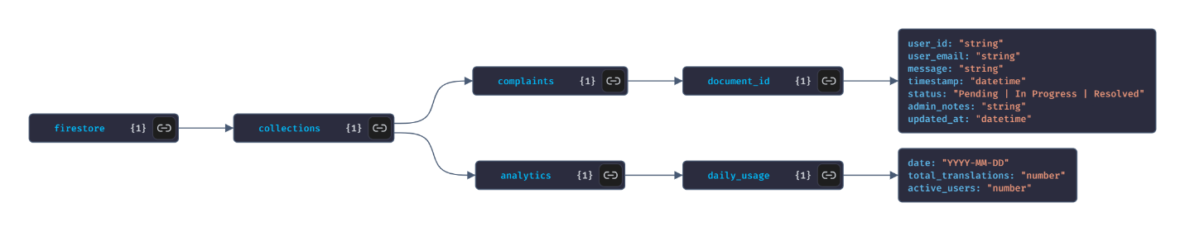
Figure 7: JSON Tree

Data design
The information domain of SignSpeak consists of three primary categories:
- User Authentication Data (managed entirely by Firebase Authentication)
- User Complaints (stored in Firebase Firestore and accessed by the admin dashboard)
- Inference Data (camera frames, extracted landmarks, and prediction outputs processed temporarily on the backend)
Only Firebase Firestore serves as a persistent database. The backend operates without a local database and processes all inference data in memory.

Cloud Database: Firebase Firestore
Firestore stores only user-submitted complaints. These are later viewed and updated by the admin through the dashboard.

Collection: complaints
Table 1: Collection Complaints
Field | Type | Description
complaint_id | string | Auto-generated Firestore ID
user_id | string | UID from Firebase Authentication
user_email | string | User’s registered email
message | string | Complaint text submitted by user
timestamp | datetime | Time of submission
status | string | “Pending”, “In Progress”, or “Resolved”
updated_at | datetime | Time when admin last modified status

Authentication Data (Firebase Auth)
Firebase Authentication automatically maintains:
- uid (user ID)
- email

Backend Internal Processing Objects
These structures exist only temporarily in memory during inference:

Landmarks (per frame)
Each detected hand landmark produces numerical coordinates:
[
[x1, y1, z1],
[x2, y2, z2],
...
]
Sequence (multiple frames)
The backend may combine a short sequence of recent landmark frames for more stable predictions:
[
[ ... landmark_vector ... ],
[ ... landmark_vector ... ]
]
(The exact number of frames is flexible and not fixed in this document.)
Prediction Result
Simple output format:
{
"predicted_word": "HELLO",
"confidence": 0.94
}
Response: Translation Output
{
"predicted_word": "<PSL_WORD>",
"confidence": <float>
}
This reflects the single-word prediction returned to the mobile app.

Data Dictionary
Table 2: Data Dictionary
Name | Type | Description
frame | string | Encoded frame sent by mobile app
landmarks | list<float> | Flattened list of coordinates extracted per frame
sequence | list<list<float>> | Recent landmark frames used for prediction
predicted_word | string | Final PSL word predicted by the backend
confidence | float | Confidence score returned by model
timestamp | datetime | Time when request was made
device_id | string | Identifier assigned by mobile app
message | string | Complaint text submitted by user
status | string | Complaint state (“Pending”, etc.)
user_id | string | Firebase UID
email | string | User’s registered email

ML Pipeline Data
The machine-learning pipeline on the backend follows a simple, implementation-agnostic structure:
Raw Frames
- Received from the mobile app
- Preprocessed (e.g., resized and converted to RGB)
- Passed to MediaPipe for hand landmark extraction
Landmark Format
- Each frame produces a fixed number of landmark points
- Coordinates include x, y, and optionally a depth value z
- Flattened into a vector for model input
Sequence Format
- A short sequence of recent frames may be combined to improve prediction stability
- Shape is flexible depending on model used
Label Encoding
{
"HELLO": 0,
"THANK YOU": 1,
"YES": 2
}

Algorithm & Implementation
This section describes the major functions of the SignSpeak system and summarizes how they operate using procedural description language (PDL) or simple pseudocode. Since the system uses a functional design, each function is represented as a standalone process.
The system has three core algorithmic components:
- Frame Reception & Processing (Backend API Layer)
- Landmark Extraction (Preprocessing Module)
- Model Inference (Recognition Module)
These operations run on the backend server only. No data is permanently stored during inference.

Frame Reception Workflow (Backend API Layer)
Purpose:
Receive a frame from the mobile app, extract landmarks, and run inference.
Pseudocode:
function handleFrame(frame, device_id):

session = getSession(device_id)

landmarks = extractLandmarks(frame)

if landmarks is invalid:
return "No landmarks detected"

add landmarks to session.recent_frames

if session does not have enough frames yet:
return "Waiting for more frames"

sequence = get recent frames from session

result = runInference(sequence)

return result

Landmark Extraction
Purpose:
Convert a single camera frame into a vector of hand landmark coordinates.
Pseudocode:
function extractLandmarks(frame):

image = decode(frame)

processed = resize(image)

detection = runHandDetector(processed)

if no hand found:
return empty landmark vector

landmarks = []

for each point in detection:
add (x, y, z) to landmarks

return landmarks

Model Inference
Purpose:
Classify the extracted landmark sequence into one PSL word.
Pseudocode:
function runInference(sequence):

if model is not loaded:
load the model

formatted = prepare(sequence)

output = model.predict(formatted)

word, confidence = decode(output)

return { word, confidence }

Software requirements traceability matrix
This matrix maps each functional requirement defined in the SRS to its corresponding design components in the SDD, associated algorithms or workflows, and the verification method used to confirm correct implementation.

Functional Requirements Traceability Matrix
Table 3: Functional Requirements Traceability matrix
Req. Number | Ref. Item (From SRS) | Design Component (From SDD) | Component Items (Functions / Algorithms)
FR-1 | UC-1 Register Account | Authentication Module | registerUser()
FR-2 | UC-2 Login | Authentication Module | loginUser(), firebaseSignIn()
FR-3 | UC-3 Capture Frames | Camera Module, Frame Sender | startCamera(),captureFrame(), sendFrame()
FR-4 | UC-4 Switch Camera | Camera Controller | switchCameraSource()
FR-5 | UC-5 Adjust Font Size | Settings Module | updateFontSize(),
FR-6 | UC-6 Manage Profile | Profile Module | loadProfile()
FR-7 | UC-7 View Dictionary | Dictionary API / Backend | fetchDictionary(), displayDictionary()
FR-8 | UC-8 Submit Complaint | Complaint Module (Firestore) | submitComplaint(), saveComplaint()
FR-9 | UC-9 Logout | Authentication Module | logoutUser(), clearSession()
FR-10 | UC-10 Detect Landmarks | Preprocessing Module | extractLandmarks()
FR-11 | UC-11 Run ML Inference | Recognition Service | runInference(), prepareInput()
FR-12 | UC-12 View Registered Users | Admin Dashboard – User Management | loadUsers(), displayUsers()
FR-13 | UC-13 View Complaints | Admin Dashboard – Complaint Viewer | loadComplaints(), filterComplaints()
FR-14 | UC-14 Respond to Complaint | Admin Dashboard – Complaint Update | updateComplaintStatus()

Non-Functional Requirements Traceability Matrix
Table 4: Non-functional Requirements Traceability matrix
Req. Number | Ref. Item | Design Component | Component Items
USE-1 | App shall allow quick access to translation | Mobile App UI / Navigation | navigationFlow(), openTranslationScreen()
USE-2 | Text must be readable; font size adjustable | Settings Module | updateFontSize(), applyFontSize()
USE-3 | Visual feedback must be clearly visible | Translation Screen UI | showPrompts(), showFeedbackIndicators()
USE-4 | UI shall guide the user with prompts | Translation Screen UI | displayGuidance(), updateUIHints()
USE-5 | Buttons/icons must meet accessibility size | UI Components | enforceButtonSize(), layoutConstraints()
PER-1 | Maintain >=15 FPS camera preview | Camera Module | startCamera(), optimizeFramePipeline()
PER-2 | Compress upload data by 20–30% | Frame Sender | compressFrame(), sendFrame()
REL-1 | App must pause safely if interrupted | Camera Module / App Lifecycle | handleInterruption(), restoreCamera()
REL-2 | Backend must maintain high availability | Backend Server | FastAPI architecture, serverDeploymentConfig()
REL-3 | App must not crash on recognition failure | Error Handling Layer | tryProcessing()
SEC-1 | App must request camera permission | Mobile App Permissions | requestCameraPermission(), checkPermissionStatus()
SEC-2 | All communication must use HTTPS | Frame Sender + Backend API | secureConnection()
PORT-1 | App shall run on Android 10+ | Flutter Mobile App | androidSDKConfig(), deviceCompatibility()
PORT-2 | Backend deployable on Ubuntu 20.04+ | FastAPI Backend | ubuntuRuntimeSetup(), serverEnvironmentConfig()
MAINT-1 | System shall follow modular architecture | SDD Component Structure | separatedModules(UI, API, ML, Admin)
MAINT-2 | ML scripts must be organized consistently | ML Pipeline Structure | organizedFolders(), preprocessingScripts()
MAINT-3 | Backend API shall support versioning | Backend API (v1) | defineVersionedRoutes(), apiVersionControl()

Human interface design
Below is the Human interface aspect of the system:

7.1 Screen images
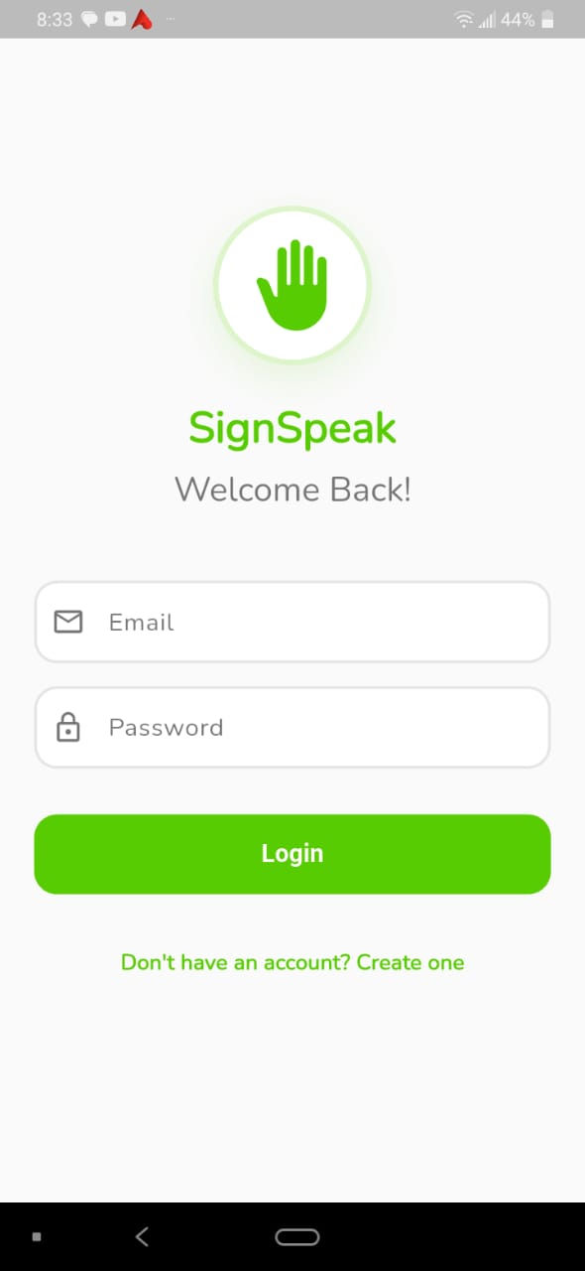
These screens represent the core user interface of the SignSpeak system, showing how users interact with key features such as authentication, sign recording, and profile management. The design ensures a consistent and intuitive experience across both web and mobile platforms. Each interface focuses on clarity, ease of use, and smooth access to primary system functions.
Figure 8: Login
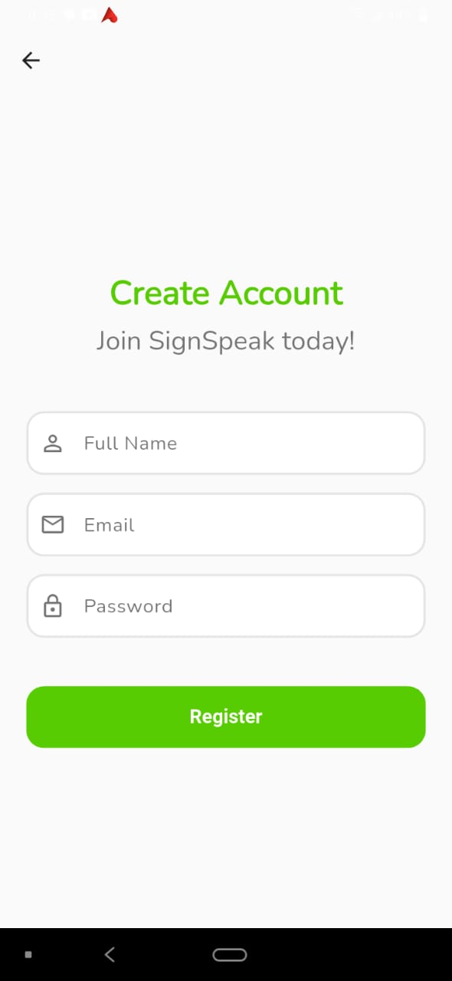
Figure 9: Register


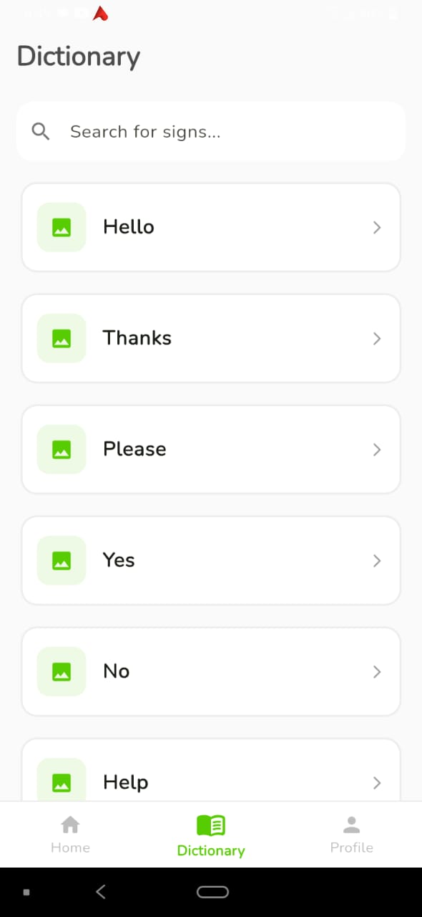
Figure 11: Translation Screen
Figure 12: Dictionary

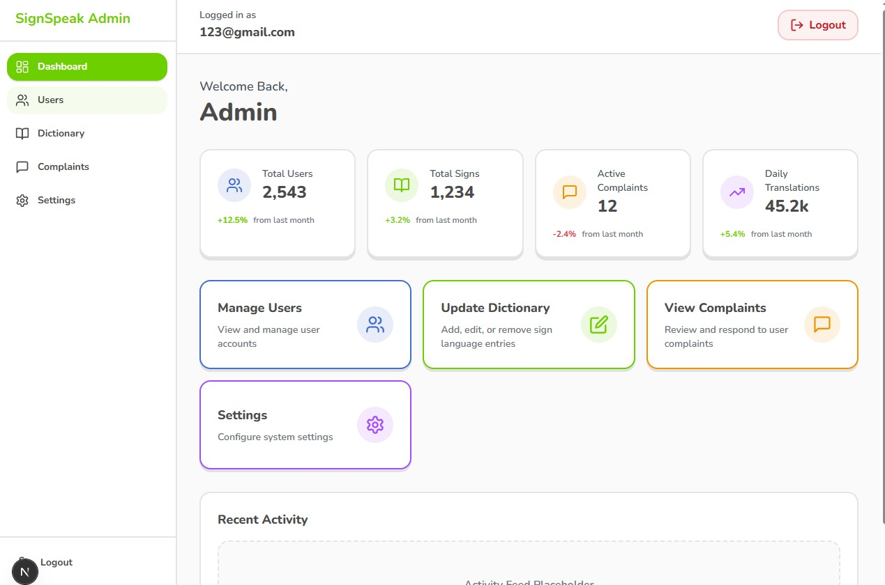
Figure 13: Admin Dashboard

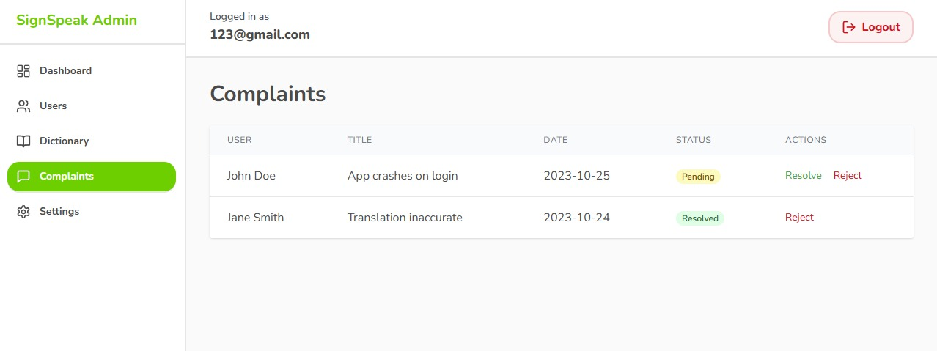
Figure 14: Admin Complaints

7.2 Screen objects and actions
The screens include common interface objects such as buttons, input fields, maps, cards, lists, and navigation bars that allow users to interact with the system. Users perform actions like logging in, starting translation, viewing dictionary, browsing the feed, and managing their profiles through these UI components. Each screen is designed so that objects are clearly placed and actions are simple, intuitive, and consistent across the application.

Appendix I
- How to design using UML (OOP): For guidance please follow the instructions mentioned in the link: http://agilemodeling.com/artifacts/

- How and when to design ER diagrams: For guidance please follow the instructions mentioned in the link:
http://people.inf.elte.hu/nikovits/DB2/Ullman_The_Complete_Book.pdf

- Data flow diagrams: For guidance please follow the instructions mentioned in the link and book:
  - http://www.agilemodeling.com/artifacts/dataFlowDiagram.htm
  - Software Engineering –A Practitioner’s approach by Roger Pressman
- Architecture diagram: For guidance please follow the instructions mentioned in the link and book:
  - Ian Sommerville – Software Engineering 9th Edition– Chapter 6

